Unit 3
Assignment
Long Vy
Purdue Global
IN450 – Advanced Software Development Using Python
Brian Myers
March 17, 2026

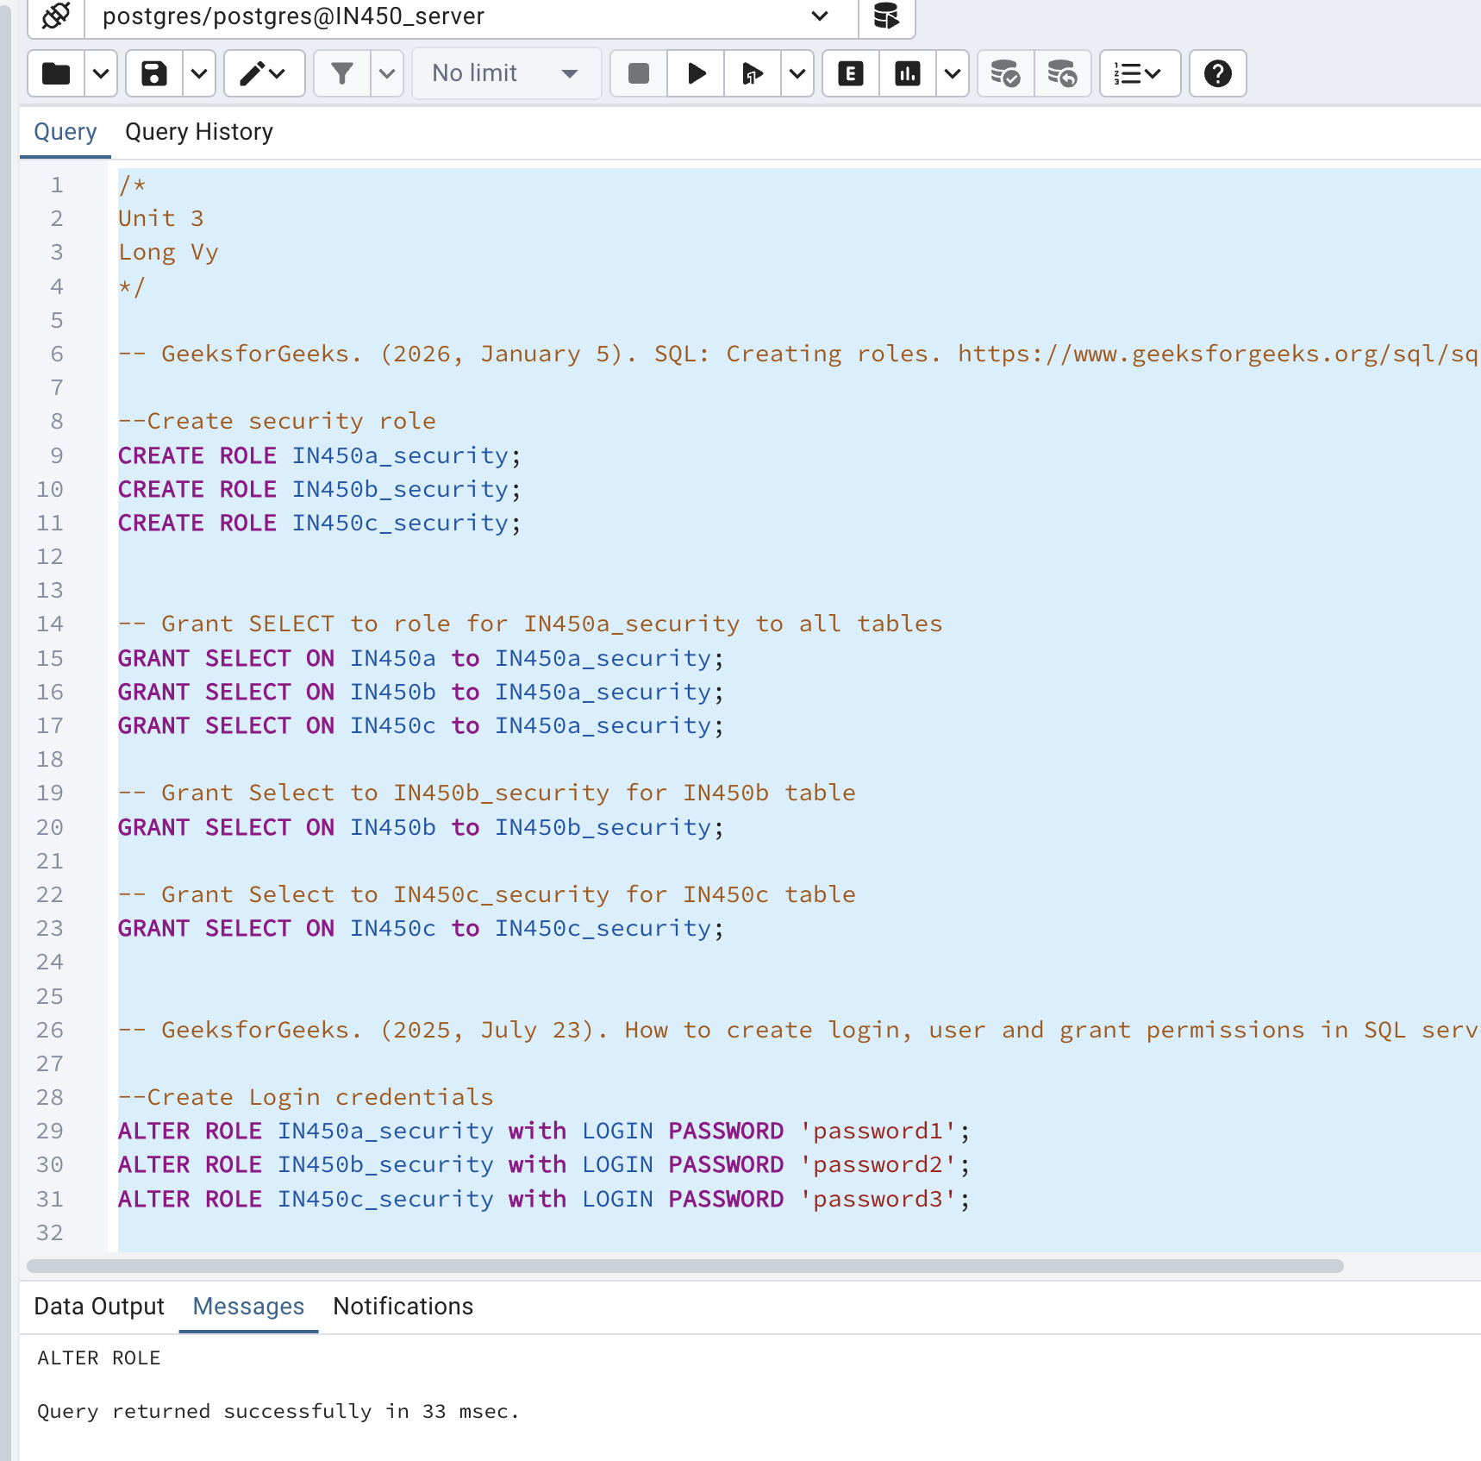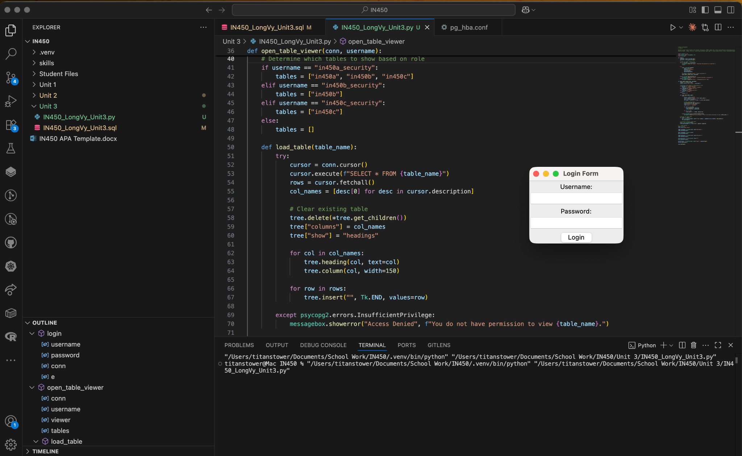
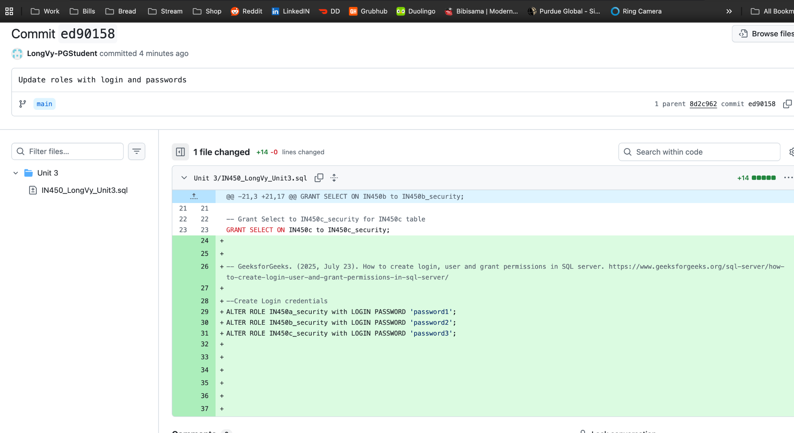

IN450a Login
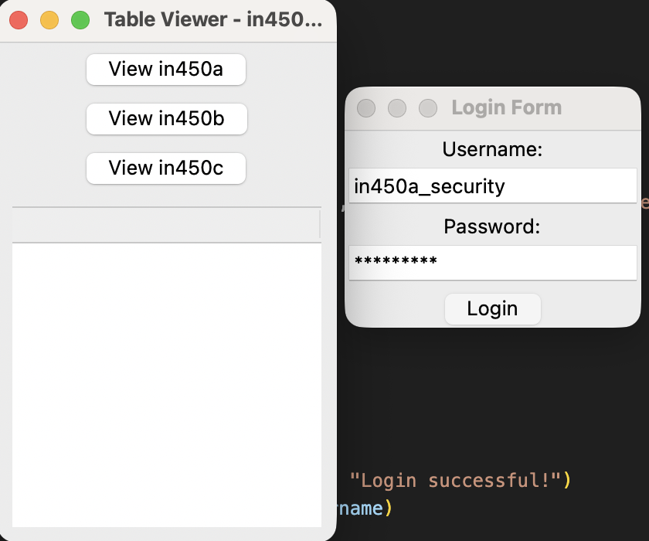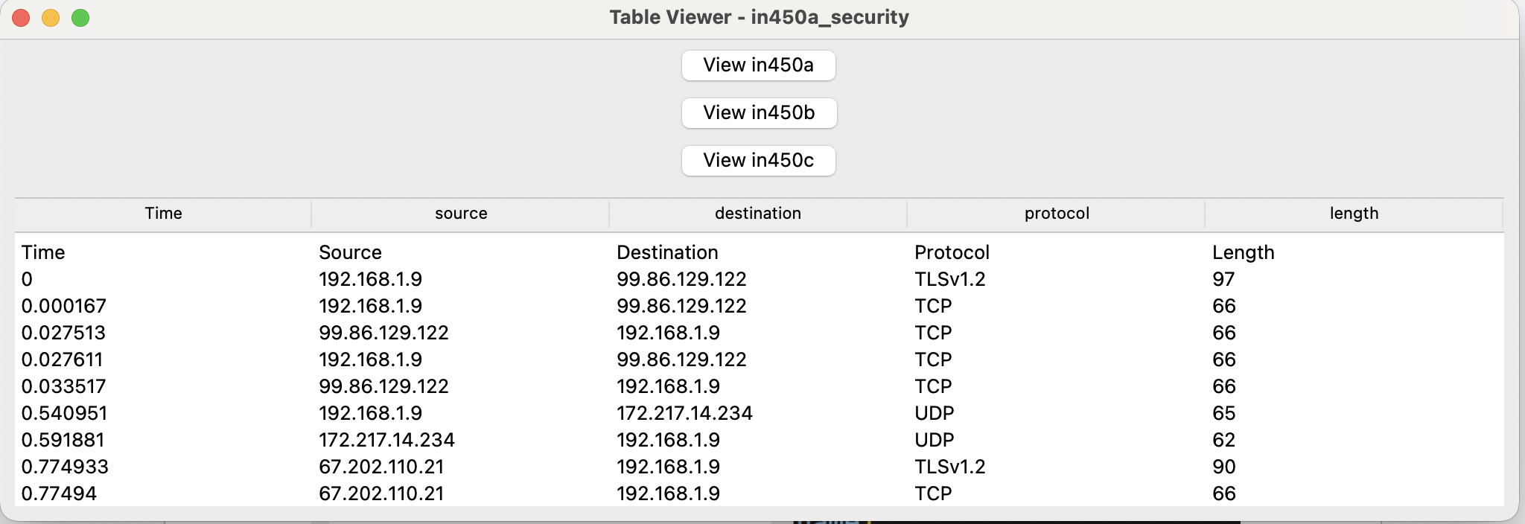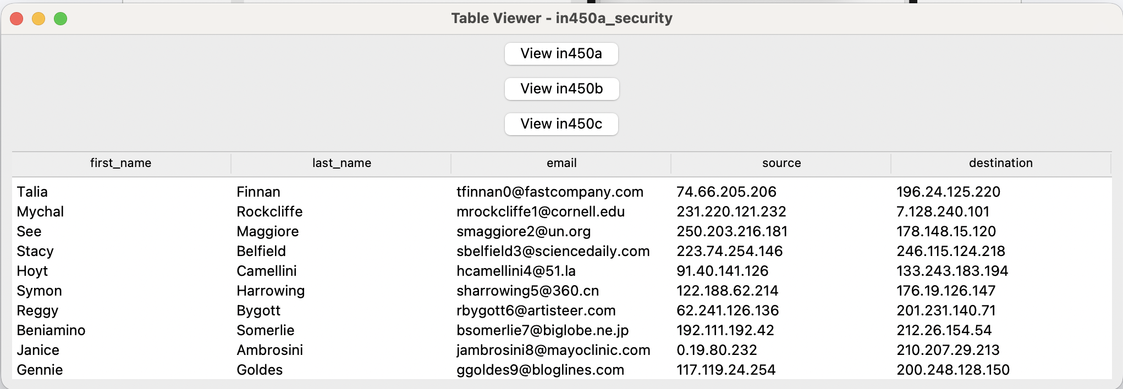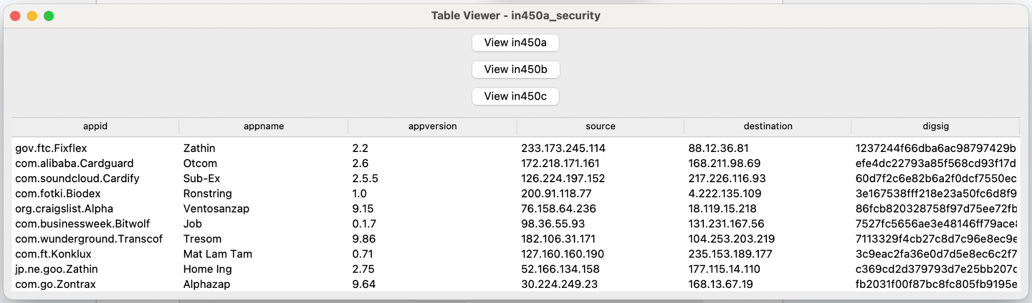
IN450b Login
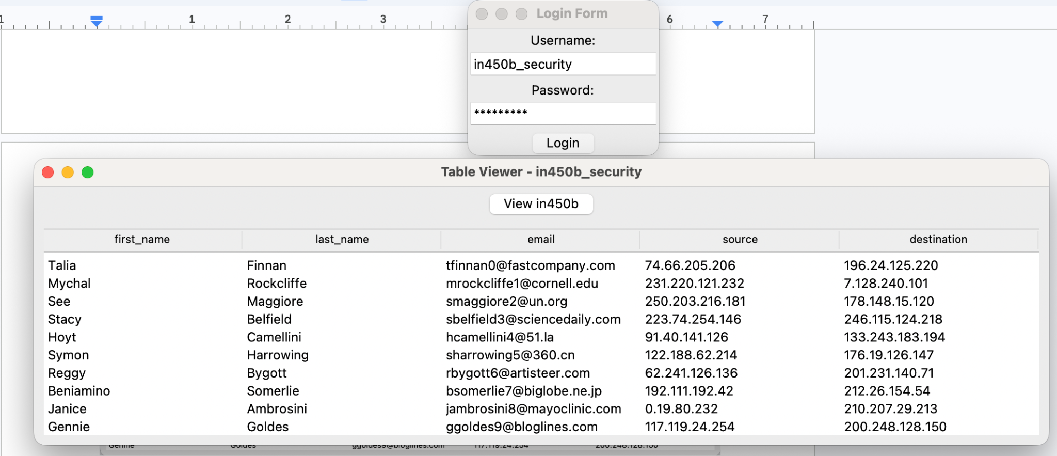
IN450c Login
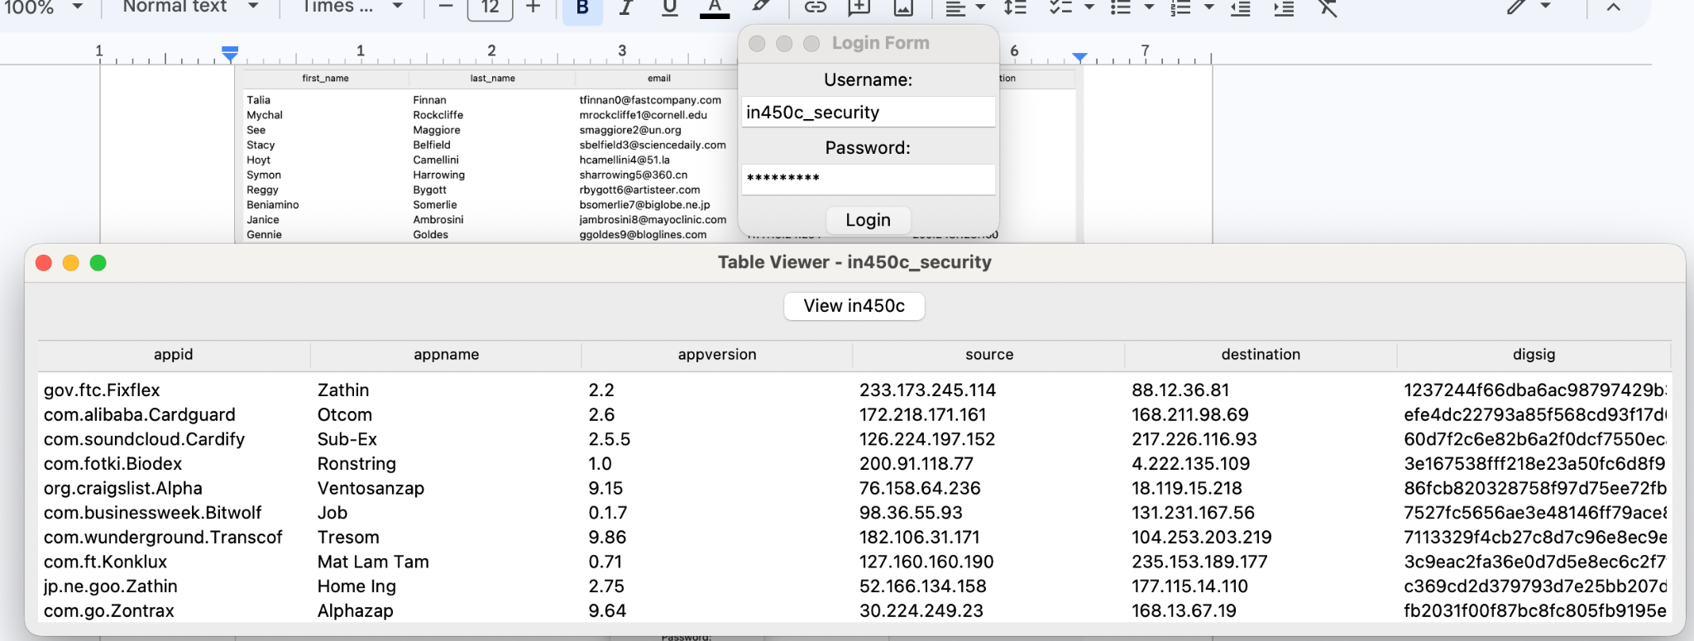

Incorrect Login
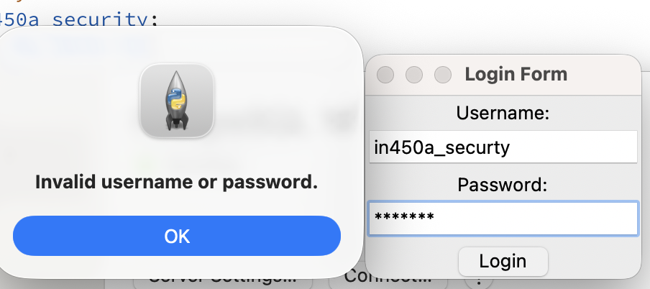
Empty login
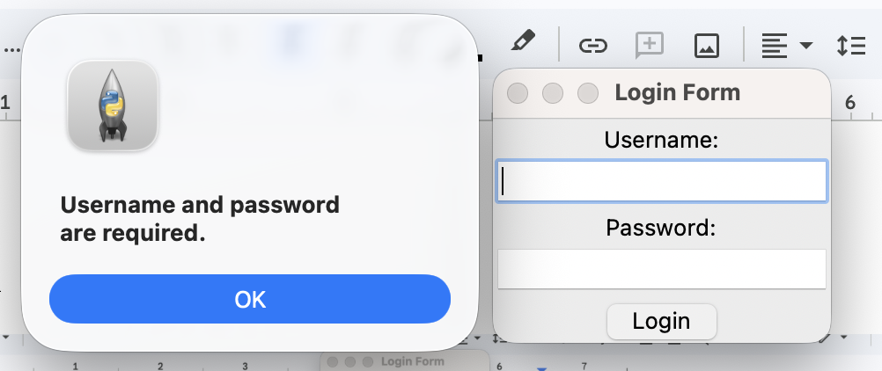

References
Create a login form in python with Tkinter. w3resource. (2025, August 12). https://www.w3resource.com/python-exercises/tkinter/python-tkinter-basic-exercise-16.php
GeeksforGeeks. (2025a, July 12). Create mysql database login page in Python using Tkinter. https://www.geeksforgeeks.org/python/create-mysql-database-login-page-in-python-using-tkinter/
GeeksforGeeks. (2025, July 23). How to create login, user and grant permissions in SQL server. https://www.geeksforgeeks.org/sql-server/how-to-create-login-user-and-grant-permissions-in-sql-server/
GeeksforGeeks. (2026, January 5). SQL: Creating roles. https://www.geeksforgeeks.org/sql/sql-creating-roles/

